

**A Project Report**

**on**

**FALL DETECTION AND MONITORING FOR THE OLDSTERS**

**For the award of**

**ONTARIO GRADUATE CERTIFICATE**

Submitted by

NAVJOT SINGH C0770551

PUNISHA PUNISHA C0777714

SIMKY ARORA C0772451

SUKHWINDER KAUR C0777211

VEERPAL KAUR C0770823

Under the guidance of

**Dr. Mike Aleshams**

**ESE-4009 Embedded System Design Engineering Project**

(MAY 2021 - AUG 2021)

**Abstract**

This project aims to develop a portable as well as a wearable device with a pulse rate sensor, temperature sensor, camera, ADXL (Accelerometer), panic button, and buzzer to detect falls. A message, high BPM, and image will be sent along with the location of the older fall to report the same to their family members or care centers. So that the old ones can get adequate care on time.

Fall-related injuries and Age are greatly related to each other. After researching similar technologies we thought about this project with all features and lower one-time cost. Our product runs on Raspbian.

After implementation, a detailed evaluation was conducted using testing techniques to evaluate product usability. The Ease of use is the central focus throughout the development. The User will get the user guide book to install and operate it.

**Acknowledgments**

We would like to express our deepest and heartiest appreciation to everyone at Embedded Systems Engineering Design Class in Lambton College, Toronto who provided us the possibility to complete this project. Special gratitude to project guide, **Dr. Mike Aleshams** whose engagement and contribution helped us coordinate our project and filing the final project report.

Thank you also to employees of JLCPCB, EASYEDA, DIGIKEY, and ORACLE community forum who provided the necessary guidance. We truly appreciate every feedback and tip on all the questions asked.

Lambton College in Toronto is a great place to study, largely because of its supporting faculty members. Thanks to all my tutors in college for supporting and encouraging our idea.

We are also grateful to our family members and friends who encourage us to go abroad and learn at Lambton College in Toronto for a bright future.

NAVJOT SINGH

PUNISHA PUNISHA

SIMKY ARORA

SUKHWINDER KAUR

VEERPAL KAUR

**Table of Contents**

**List of Figures………………………………………………………………………………..6-7**

**Chapter I - Introduction…………………………………………………………………….8-10**

**Overview……………………………………………………………………………………………8**

Problem Statement…………………………………………………………………………………..8

Goal and Objective…………………………………………………………………………………..8

Scope of Project……………………………………………………………………………………..8

Outcomes and Benefits……………………………………………………………………………...10

Facilities and Resources……………………………………………………………………………..10

Procedure and Methodology………………………………………………………………………...10

**Chapter II – Literature Review……………………………………………………....…….11-12**

**Chapter III – Requirement and Analysis………………………………………………….13-15**

Hardware…………………………………………………………………………………………....13

Software……………………………………………………………………………………………..14

Power Requirement………………………………………………………………………………….14

Product Development Block Diagram………………………………………………………………15

**Chapter IV – Design………………………………………………………………………………..16**

Fall Detection System…………………………………………...…………………………………..16

Components ………………………………………………………………………………………...17-30

Creating the Schematic………………………………………………………………………….. …31

Gerber File…………………………………………………………………………………………..32-33

**Chapter V – Implementation and Test…………………………………………………………34-**

Flow chart…………………………………………………………………………………………...34

Raspberry Pi4……………………………………………………………………………………….35-36

Raspberry pi testing with LED……………………………………………………………………..37-39

Code Interfacing…………………………………………………………………………………....40-54

Code Integration……………………………………………………………………………………55-56

Plug and Play………………………………………………………………………………………57

**Chapter VI – Evaluation………………………………………………………………………...58**

Introduction………………………………………………………………………………………..58

Minimum Requirements…………………………………………………………………………..58

Troubleshooting…………………………………………………………………………………...58-59

**Chapter VII – Conclusion………………………………………………………………………60**

Future Work……………………………………………………………………………………....60

**Chapter VIII – User’s Guide…………………………………………………………………..61-63**

Powering up………………………………………………………………………………………..61-32

Instructions……………………………………………………………………....………………….62-63

**References………………………………………………………………………………………...64-69**

**List of Figures**

| Figure No. | Description |
| --- | --- |
| 2.1 | Engineering Design idea |
| 3.1 | Lithium-ion batteries |
| 3.2 | Block Diagram of Product Development |
| 4.1 | Block diagram of the fall detection system |
| 4.2 | Panic button image |
| 4.3 | Released State Internal Circuit Diagram |
| 4.4 | Temperature Sensor |
| 4.5 | Buzzer Pins |
| 4.6 | Regulator Pin Configuration |
| 4.7 | ADXL Pin Configuration |
| 4.8 | Released State Internal Circuit Diagram |
| 4.9 | ESP32 CAM |
| 4.10 | Arduino UNO |
| 4.11 | Raspberry PI 4 & Pins configuration |
| 4.12 | GSM MODULE |
| 4.13 | GPS MODULE |
| 4.14 | EasyEDA Software |
| 4.15 | what PCB look like |
| 4.16 | Schematic Design |
| 4.17 | PCB Layout Design |
| 4.18 | PCB Fabrication File |
| 5.1 | Flow chart of Fall Detection and Monitoring system |
| 5.2 | Raspberry Pi |
| 5.3 | Raspbian Set Up |
| 5.4 | Hardware connections to test RPI |
| 5.5 | Breadboard connections for testing |
| 5.6 | Terminal commands for testing |
| 5.7 | Active High Pull Up Circuit |
| 5.8 | Active High Pull Up Circuit |
| 5.9 | Testing Panic Button with Raspberry Pi |
| 5.10 | C++ Code For Testing Panic Button with Raspberry Pi |
| 5.11 | ESP32 with RASPBERRY PI |
| 5.12 | Fig. 5.12 wiring of Pulse Rate Sensor with Raspberry Pi4 using Arduino |
| 5.13 | Code for GSM |
| 5.14 | Raspberry Pi4 header pin connections with all components |
| 5.15 | Execution of Code |
| 8.1 | Raspberry Pi4 powered up |
| 8.2 | Blynk App installation from App store |
| 8.3 | Panic Button on the device |

**Chapter I**

**Introduction**

**Overview**

Fall is a big concern to public and health safety, especially among the oldsters as their physical fitness deteriorates, a timely and effective monitoring is needed to reduce the negative effects of falls. To overcome this issue, we are proposing a wearable device that will not only detect any fall through ADXL345 but also monitor the pulse rate, the temperature of the old person, also the system will capture the images and send them to the cloud so that medical assistance can be given on time. The Cost of product development ranges between $400-$500.

**Problem Statement**

Age and injuries linked with falls are correlated. Therefore, How we fall into old age is totally different from as kids. The force, distance, and size are greater as compared to kids. The ability to grab nearby support and manage your body movement to avoid the hard landing is more efficient in kids and young people, but not in oldsters. The second thing is the reaction time with age changes and gets slower with aging. Now is the perfect time to develop a portable and wearable device that can be used to detect any fall and report it on time.

The existing medical alert systems such as the Bay alarm system, Medical Guardian, etc. fall into four categories: equipment costs, monthly monitoring fees, add-ons, and hidden fees. The biggest limitation is cost, as buyers need to pay monthly charges as per their plans. But Our system is a one-time investment as there will be no monthly charges.

**Goal and Objectives**

* **Goal**

Develop a portable belt with a camera and running a raspbian operating system by the end of the Summer 2021 Academic term.

* **Objective**
* Connecting a host processor Raspberry Pi4 with ADXL345, pulse rate sensor, temperature sensor, panic button, and buzzer.
* Adding an ESP32 camera with the system to send images on the cloud.
* Connecting GSM and GPS Modules to communicate with the user end.

**The Scope of the Project**

* **Deliverable**
* A waist wearable belt with all the components placed on it.
* Wi-Fi, USB, BLYNK App, and cloud storage capabilities.
* 6000mAh battery with a recharging case.
* **Milestones**

| **S. No.** | **Task** | **Start Date** | **End Date** | **Name** |
| --- | --- | --- | --- | --- |
| 1 | Project Proposal | May 19 | June 3 | Group |
| 2 | Deciding and Buying Hardware  Components | June 4 | June 10 | Punisha |
| 3 | Capture Plan Schematic | June 10 | June 14 | Veerpal |
| 4 | Regulator and Power management | June 14 | June 16 | Simky |
| 5 | Setting and Testing Raspberry Pi 4 | June 15 | June 17 | Navjot |
| 6 | Testing of components (Part 1) e.g input sensors | June 18 | June 21 | Sukhwinder |
| 7 | Testing components (Part 2) e.g GSM, GPS module. | June 22 | June 23 | Veerpal |
| 8 | Interfacing Buzzer with Rpi4 | June 25 | June 28 | Punisha |
| 9 | Interfacing of Panic Button with Rpi4 | June 29 | June 30 | Navjot |
| 10 | PCB Layout Design | July 1 | July 5 | Sukhwinder |
| 11 | Interfacing ADXL345 with RPi 4 | July 5 | July 7 | Simky |
| 12 | Interfacing of GSM Module with RPi4 | July 7 | July 12 | Navjot |
| 13 | Interfacing of GPS Module with RPi4 | July 13 | July 14 | Punisha |
| 14 | Interfacing of Temperature Sensor | July 14 | July 19 | Veerpal |
| 15 | Interfacing Pulse Rate Sensor with RPi4 | July 19 | July 21 | Sukhwinder |
| 16 | Interfacing of ESP32 CAM | July 21 | July 22 | Simky |
| 17 | Cloud storage management | July 22 | July 26 | Sukhwinder |
| 18 | Real-Time Operation | July 26 | July 28 | Veerpal |
| 19 | Code integration | July 28 | Aug 4 | Punisha |
| 20 | Zero PCB Implementation of Hardware pt1 | Aug 5 | Aug 9 | Navjot |
| 21 | Zero PCB Implementation of Hardware pt2 | Aug 9 | Aug 12 | Simky |
| 22 | Report Finalization | Aug 12 | Aug 16 | Group |
| 23 | Final Presentation(Demo) | Aug 16 | Aug 19 | Group |

* **Limitations**
  + Power: Rechargeable batteries are used so after a specific time, power gets drained. Until we recharge them again, there will be no functioning.
  + The user needs to set up the BLYNK application.
  + The user needs an internet connection to open Location and Image URLs.

**Outcomes and Benefits**

* The user will get the exact location.
* BPM and Temperature values will be notified.
* A photo will be captured and uploaded on the cloud and it will be on a public network.
* Lightweight and portable.
* Robust and user-friendly.

**Facilities and Resources**

* **Laboratory**
  + Embedded Systems Software.
  + Multimeter, logic analyzers, and Raspbian installed PCs.
* **Intellectual Resources**
  + Datasheets of Raspberry pi 4, Arduino UNO, and all other components
  + Exploring VNC Viewer and Arduino IDE.

**Procedure and Methodology**

1. Download and launch the Raspberry Pi Imager from<https://www.raspberrypi.org/software/>
2. Select the OS and SD card to install the files.
3. After a few seconds of booting. Setup Raspberry Pi.
4. Click on the network icon in the top right side corner of the window, and select your network from the drop-down menu. Connect it with your wifi.
5. Then install and set up VNC Viewer to enable RPI ports.
6. Attach all the components like Temperature Sensor, Pulse rate sensor, Buzzer, Panic Button, ADXL345, Arduino Uno, GSM, and GPS Modules with the help of jumper wires and USB cables.
7. Upload the program and Compile it. The project will start working.

**Chapter II**

**Literature Review**

1) As of now, a few arrangements have been proposed for older fall identification. Such arrangements are classified into three principle types as indicated by the sensor-innovation utilized: Non-Wearable Based Systems (NWS), Wearable Based Systems (WS), and Fusion or crossover based Systems (FS).

WS frameworks like 8910 had proposed the idea which was a rule to utilize inertial sensors like accelerometers and whirligigs, ordinarily appended to the body of the older for development and acknowledgment when a fall happens. Specifically, accelerometers are being utilized progressively in WS frameworks since they offer benefits, for example, low force utilization, minimal expense, low weight, simplicity of activity, little size, can be mounted on the different body areas, and, above all, compactness. Therefore, perhaps the most ordinarily utilized strategy for fall discovery includes the utilization of a tri-pivotal accelerometer. Second, the fall of a senior is recognized by a choice trees-based Big Data model which is fabricated and prepared in the cloud. At last, the fall occasions recognized are put away in the cloud to give more exact data to medical services experts. Furthermore, this information is utilized to fabricate another model each time a fall is recognized, which is resulting in the Smart IoT Gateway. (Diana Yacchirema, 2018).

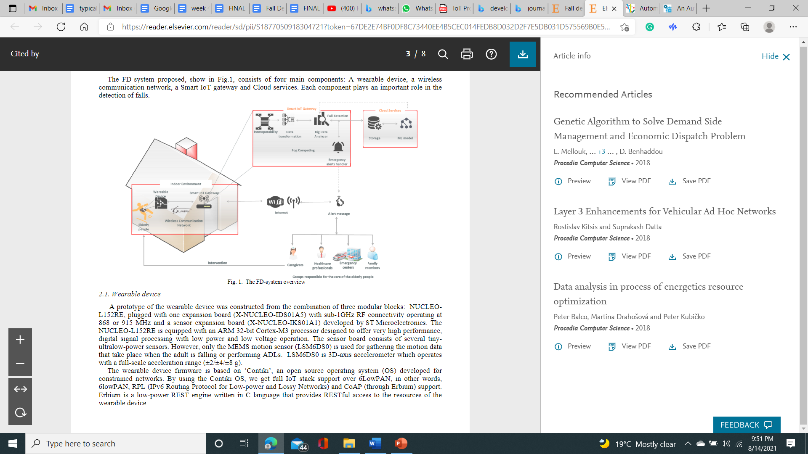

Fig 2.1. Engineering Design idea

2) Our cutting-edge social orders are experiencing the increment of the older populace while simultaneously the government-backed retirement and wellbeing costs should be chopped down. To keep away from the need for unique habitats, the genuine pattern is to urge old people to remain living independently in their own homes as far as might be feasible. The item introduced in this paper adds to this goal since it gives client restriction, programmed fall location, and movement observing both for inside and outside exercises, related to a total call place for clinical checking of the patient just as to offer help. (Guillaume Perolle, 2007).

3) Falls are the leading cause of injury in older people. Reducing falls could reduce financial pressures on health services. (Matthew, 2016) He carried out this research to develop a falls risk model, using routine primary care and hospital data to identify those at risk of falls, and apply cost analysis to enable commissioners of health services to identify those in whom savings can be made through referral to a falls prevention service.

4) The reaction time with age changes and gets slower with aging. A study used a computer system named Nintendo Wii computer system to note the reaction time of different ages. People from different age groups needed to react to a visual signal by striking a keyboard, where it is found that old people react comparatively slower than other age groups. (Shmerling,2016).

5) In old age, people are more prone to get injured by falling from a certain height.

Falls are the leading cause of injury in older people. (Smith, Tickner & Jones, 2016 ) At this particular age, broken bones and bruises take more time to heal and can be more serious compared to a person at a younger age.

6) Almost 30 percent of elderly people fall once a year at least. At the age of 70+, most of the death occurs due to falling events. (Perolle,Fraisse & Mavros,2007).

* Adults older than 65 years of age suffer the greatest number of fatal falls.
* 37.3 million falls that are severe enough to require medical attention occur each year. (WHO,2018).
* A similar study was done by (“[Seniors' Falls in Canada: Second Report - Canada.ca](https://www.canada.ca/en/public-health/services/health-promotion/aging-seniors/publications/publications-general-public/seniors-falls-canada-second-report.html),” n.d.).

7) T[raumatic brain injury](https://utswmed.org/conditions-treatments/brain-and-spine-trauma/) (TBI) is one of the most common medical problems caused by falls. “More than 80 percent of TBI in adults aged 65 and older is [caused due to falls](http://www.cdc.gov/traumaticbraininjury/get_the_facts.html).”(Bell,2016).

**Chapter III**

**Requirements / Analysis**

**Hardware** 

This wearable device requires the Raspberry Pi4 microprocessor as the central processing unit which runs on Raspbian and Arduino Uno as a supportive microprocessor for Raspberry Pi4 to give the output result of the Pulse rate sensor. The other components like ADXL345, panic button, buzzer, and ESP32 Camera are attached with the Raspberry Pi4. Furthermore, the GSM and GPS module is connected with the device to send the message and to get the exact location of the oldster. All the components are surface mounted on the PCB.

Our product is useful for both indoor and outdoor purposes because it is portable and wearable. It is also a plug-and-play device. It does not need any external source to boot up like any personal computer.

Following are the list of required hardware components for this project:

* Raspberry Pi4: It is a SOC (System On Chip) which consists of a processor, memory, and graphics chip making it a single-board computer without any integrated peripheral devices like a screen, keyboard**.**
* ADXL345: This ADXL345 Accelerometer module consists of an Accelerometer IC, Voltage Regulator IC, Level Shifter IC, resistors, and capacitors in an integrated circuit.
* Temperature Sensor: The DS18B20 Digital Thermometer provides 9 to 12-bit (configurable) temperature readings which indicate the temperature of the device.
* Panic Button: The panic button is the device that the person activates when he or she needs help.
* Pulse Rate Sensor: This is a heartbeat detecting and biometric pulse rate sensor.
* Buzzer: Buzzers are a simple and inexpensive means of providing communication between electronic products and the user.
* GPS: NEO-6M GPS module EEPROM built-in active antenna ensures strong signal with data backup battery. When the power is down it stores data and it also has an LED signal indicator.
* GSM: The SIM7600A-H 4G HAT is a 4G communication and GNSS(Global Navigation Satellite System) positioning module, which supports LTE CAT4 up to 150Mbps for downlink data transfer.
* ESP32 CAM: A feature-rich MCU with integrated Wi-Fi and Bluetooth connectivity for a wide range of applications. It combines Wi-Fi and Bluetooth wireless capabilities and dual-core. ESP32 can perform as a complete standalone system or as a slave device to a host MCU. ESP32 can interface with other systems to provide Wi-Fi and Bluetooth functionality through its SPI / SDIO or I2C / UART interfaces.

**Software** 

To interface all the components and microcontrollers together we need compatible software and programs. Considering software requirements, for developing this compatibility we are using the Raspbian operating system along with a virtual desktop which is a VNC viewer. We used Geany as a programmer’s text editor. After setting up Raspberry Pi4, VNC, Geany, we have successfully interfaced all the programs.

Following is a list of required software for this project:

* Download and launch the Raspberry Pi Imager from<https://www.raspberrypi.org/software/>
* VNC viewer: install and set up VNC Viewer to enable RPI ports.
* GEANY: C/C++ programming
  + C/C++ programming skills will be needed to interface all the components to fulfill the requirement.
  + VNC viewer terminal is used to compile and execute the program.

**Power Requirement** 

To function, all the components consume power. Raspberry pi 4(3000 MAh) and GSM module (2500 MAh)are the components with higher consumption.

Other components have minimal power consumption

•Total consumption = 5700 mA

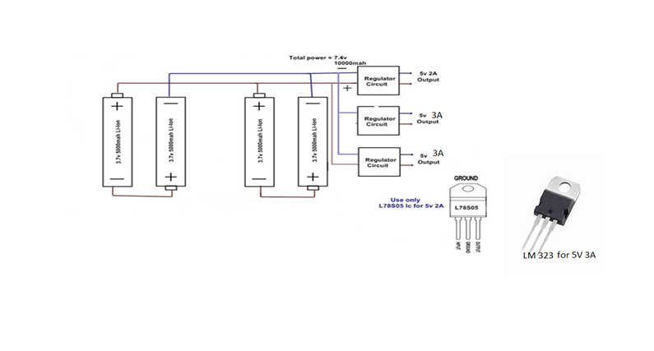

Fig. 3.1 Lithium-ion batteries

We are going to use 4 batteries.

•2 batteries are in series and the other 2 are in parallel with these cells.

•2 regulators have been used from those, 1 regulator is used for 5V 2A supply and others are used for 5V 3A supply.

**Product Development Block Diagram**



Figure 3.2 Block Diagram of Product Developmen*t*

The above figure shows the flow of product development. All testing of the device is performed under the guidance of the class instructor and internet resources such as Oracle, WiringPi, EasyEDA, etc.

**Chapter IV**

**Design**

**Fall Detection System**

After careful consideration of the idea about Fall detection and monitoring devices, we came up with a block diagram for this. This helps further in designing and knowing how we will attach all the components.

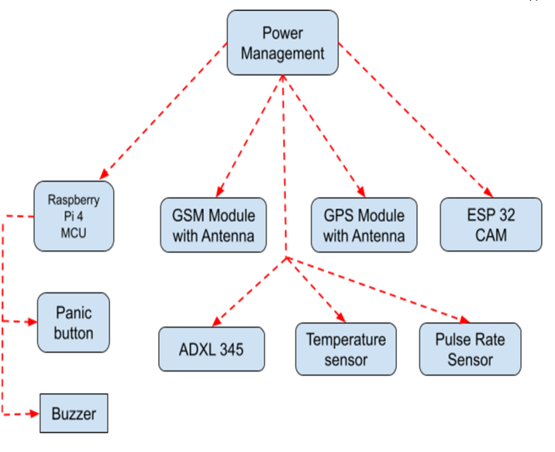 Fig. 4.1 Block diagram of fall detection system

**Components:**

**Panic button**

Push-button is often called a Push Switch. We use switches as actuators for any action-based work. So, it is a momentary and non-latching button that changes circuit logic for a temporary time and we physically actuate it or press it.

**Types:**

* 4 Terminal Push Button
* 2 Terminal Push Button

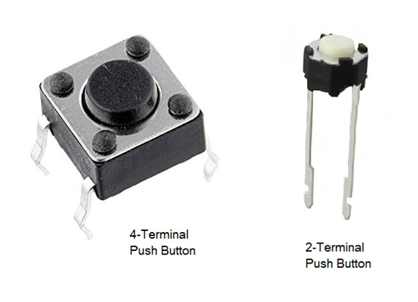

Fig.4.2 Panic button image

**Pressed State Internal Circuit Diagram:**

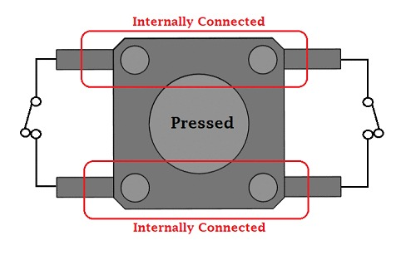

Fig.4.3 Released State Internal Circuit Diagram

**Temperature Sensor**

* DS18B20 (Digital thermometer), The DS18B20 Digital Thermometer provides 9 to 12-bit (configurable) temperature readings that indicate the temperature of the device.
* Information is sent to/from the DS18B20 over a 1-Wire interface so that only one wire (and ground) needs to be connected from a central microprocessor to a DS18B20. Power for reading, writing, and performing temperature conversions can be derived from the data line itself with no need for an external power source.
* As we are designing a system that can detect the fall indoor as well as outdoor, so it is good if the system is able to bear the weather and DS18B20 is a perfect choice as it is waterproof and has a long probe to use over a distance if we want.
* The connections areas:
* Connect the VCC(Red) pin of DS18B20 to the 5v pin of RPI4.
* Connect the GND(Black) pin of DS18B20 to the GND pin of RPI4.
* Data pin(Yellow) is data that goes to GPIO pin 24 on RPI4.

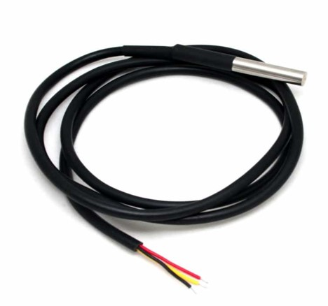

Fig.4.4 Temperature Sensor

**Features:**

•Unique 1-Wire interface requires only one port pin for communication.

• Multidrop capability simplifies distributed temperature sensing applications.

•Requires no external components.

•Can be powered from a data line. The power supply range is 3.0V to 5.5V.

•Measures temperatures from -55°C to +125°C..

• Fahrenheit equivalent is -67°F to +257°F .

• ±0.5°C accuracy from -10°C to +85°C.

**Buzzer**

**write little about it**

A buzzer or beeper is an audio signaling device, which may be mechanical, electromechanical,or piezoelectric (piezo for short).Typical uses of buzzers and beepers include alarm devices, timers, and confirmation of user input such as a mouse click or keystroke.

There are 3 pins:

VCC: 3.3V - Buzzer needs a power supply of 3.3V

Ground - This pin needs to be connected to Raspberry pi 4’s Ground

I/O: This is the pin Connected to GPIO 21.

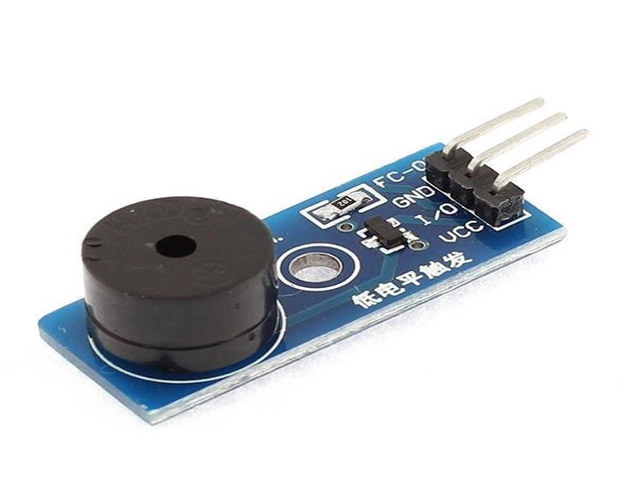

Fig.4.5 Buzzer Pins

### **Buzzer Features and Specifications:-**

* Rated Voltage: 6V DC
* Operating Voltage: 4-8V DC
* Rated current: <30mA
* Sound Type: Continuous Beep
* Resonant Frequency: ~2300 Hz
* Small and neat sealed package
* Breadboard and Perf board friendly

**Regulators**

A voltage regulator is an [integrated circuit](https://www.jameco.com/webapp/wcs/stores/servlet/JamecoSearch?langId=-1&storeId=10001&catalogId=10001&categoryName=category_root&subCategoryName=ICs%20%26%20Semiconductors&category=10&jameco_page=54) (IC) that provides a constant fixed output voltage regardless of a change in the load or input voltage.

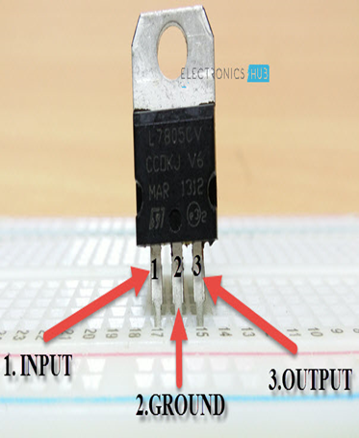

Fig.4.6 Regulator Pin Configuration

**Specifications :**

•Output current up to 2 A

• Output voltages of 5; 7.5; 9; 10; 12; 15; 18; 24 V

• Thermal protection

• Short circuit protection

• Output transition SOA protection (safe operating area)

**LM323 IC and its specifications :**

•The LM323, A are monolithic integrated circuits that supply a fixed positive 5.0 V output with a load driving capability in excess of 3.0 A

•Features

• Output Current in Excess of 3.0 A

• Available with 2% Output Voltage Tolerance

• No External Components Required .

18650 batteries are lithium-ion batteries. They get their name from their size: 18mm by 65mm. These batteries are not only used in flashlights, but also in: power tools, electric vehicles, vaporizers, cameras, laptops, and more! . It usually takes about 3 hours to charge a 18650 lithium-ion battery fully.

•We are going to use 4 batteries .

**ADXL 345** 

The ADXL345 is a low-power, 3-axis MEMS accelerometer module with both I2C and SPI interfaces. The Adafruit Breakout boards for these modules feature on-board 3.3v voltage regulation and level shifting which makes them simple to interface.

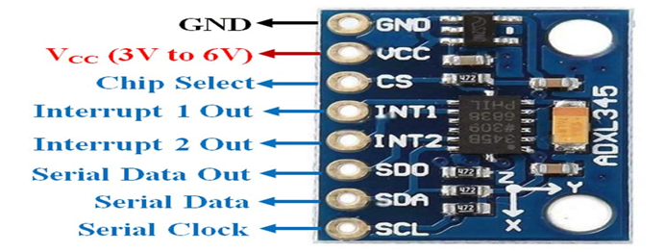

Fig.4.7 ADXL Pin Configuration

**Features:**

* Ultralow power: as low as 23 μA in measurement mode and 0.1 μA in standby mode at VS = 2.5 V (typical)
* Power consumption scales automatically with bandwidth
* User-selectable resolution
  + Fixed 10-bit resolution
  + Full resolution, where resolution increases with *g* range, up to 13-bit resolution at ±16 *g* (maintaining 4 mg/LSB scale factor in all *g* ranges)
* See data sheet for additional features.

**Pulse rate sensor**

An optical heart rate sensor measures pulse waves, which are changes in the volume of a blood vessel that occur when the heart pumps blood.

* 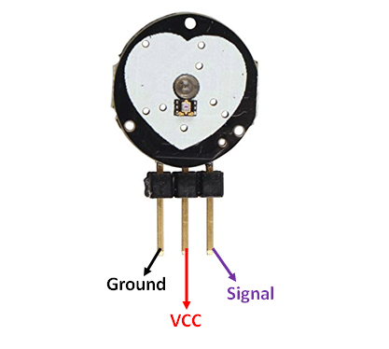
* Fig.4.8 Released State Internal Circuit Diagram

Ground - Black - Connected to the ground of the system

Vcc - Red - Connect to +5V or +3.3V supply voltage

Signal - Purple - Pulsating output signal.

**Features:**

* Biometric Pulse Rate or Heart Rate detecting sensor
* Plug and Play type sensor
* Operating Voltage: +5V or +3.3V
* Current Consumption: 4mA
* Inbuilt Amplification and Noise cancellation circuit.
* Diameter: 0.625”
* Thickness: 0.125” Thick

**ESP32 CAM:**

The ESP32 is a dual-core system,All embedded memory, external memory and peripherals are located on the data bus and/or the instruction bus.

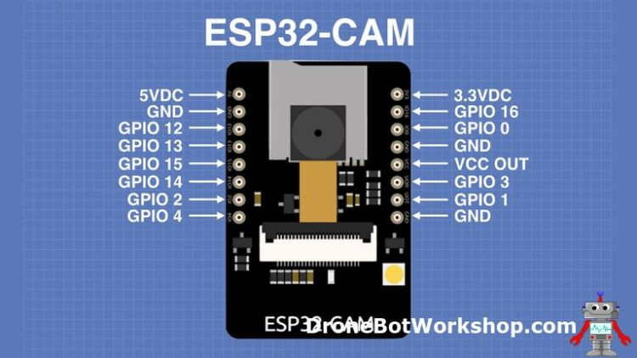

Fig.4.9 ESP32 CAM

**Technical characteristics of ESP32-CAM:-**

•The ESP32-CAM module has some technical characteristics that you can see in the datasheet manufacturer. Here I summarize the most important ones:

•Connectivity: WiFi 802.11b / g / n + Bluetooth 4.2 with BLE. Supports image upload via WiFi.

•Connections: UART, SPI, I2C and PWM. It has 9 GPIO pins.

•Clock frequency: up to 160Mhz.

Microcontroller computing power: up to 600 DMIPS

•EXTRAS: has multiple sleep modes, firmware upgradeable by OTA, and LEDs for use of built-in flash memory.

•Camera: Supports OV2640 cameras that can come in the pack or be purchased independently. These types of cameras have:

•2 MP on your sensor

•1622 × 1200 px UXGA array size

## 

**Arduino UNO**

Arduino Uno is a microcontroller board based on the ATmega328P (datasheet). It has 14 digital input/output pins (of which 6 can be used as PWM outputs), 6 analog inputs, a 16 MHz ceramic resonator (CSTCE16M0V53-R0), a USB connection, a power jack, an ICSP header and a reset button. It contains everything needed to support the microcontroller; simply connect it to a computer with a USB cable or power it with a AC-to-DC adapter or battery to get started.

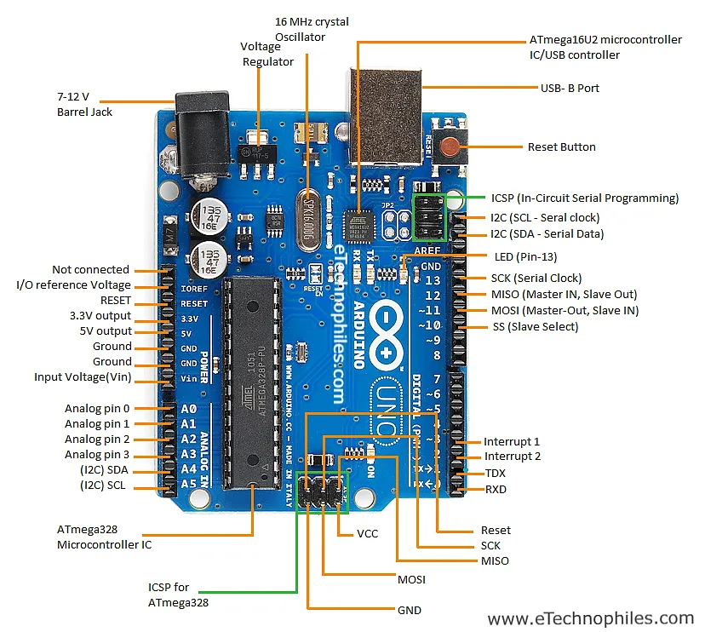

Fig.4.10 Arduino UNO

## **Specifications of Arduino UNO:**

* Microcontroller: ATmega328p
* Operating Voltage: 5V
* Input Voltage (recommended): 7-12V
* Input Voltage (limits): 6-20V
* Digital I/O Pins: 14 pins (of which 6 are PWM output pins)
* Analog Input Pins: 6
* DC Current per I/O Pin: 40 mA
* DC Current for 3.3V Pin: 50 mA
* Flash Memory: 32 KB (of which 0.5 KB is taken by bootloader)
* SRAM: 2 KB (ATmega328)
* EEPROM: 1 KB (ATmega328)

**RASPBERRY PI 4**

It is a SOC (System on Chip) which consists of processor, memory, and graphics chip making it a single-board computer without any integrated peripheral devices like screen, keyboard**.**

* 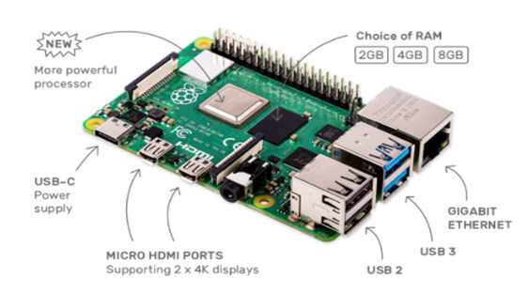
* 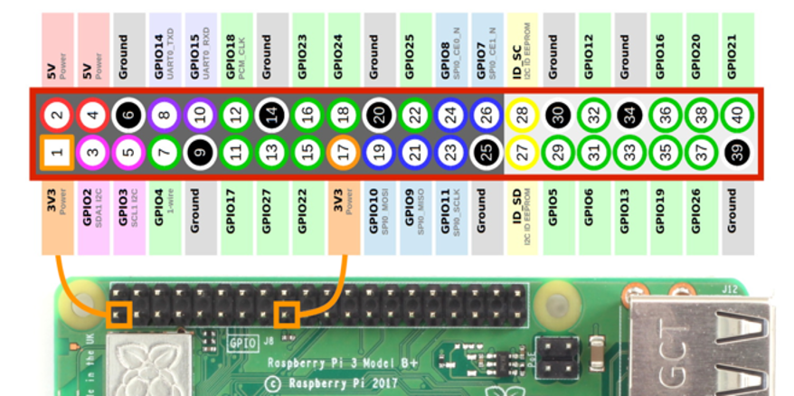
* Fig.4.11 Raspberry PI 4 & Pins configuration
* **Specifications :**
* Comes with Broadcom BCM2711, Quad-core Cortex-A72 (ARM v8) 64-bit SoC 1.5GHz processor
* 4 GHz and 5.0 GHz IEEE 802.11ac wireless, Bluetooth 5.0, BLE
* Carries Gigabit Ethernet to connect computers in physical space
* RAM is available with different memories. Pick from 2GB, 4GB, or 8GB LPDDR4-3200 SDRAM (depending on model)
* 2-lane MIPI DSI display port
* 2-lane MIPI CSI camera port
* One USB 3.0 port; One USB 2.0 port and One USB-C power port.
* **GSM MODULE**
* 
* GSM technology was developed as a digital system using the time division multiple access (TDMA) technique for communication purposes. A GSM digitizes and reduces the data, then sends it down through a channel with two different streams of client data, each in its own time slot. The digital system can carry 64 kbps to 120 Mbps of data rates.

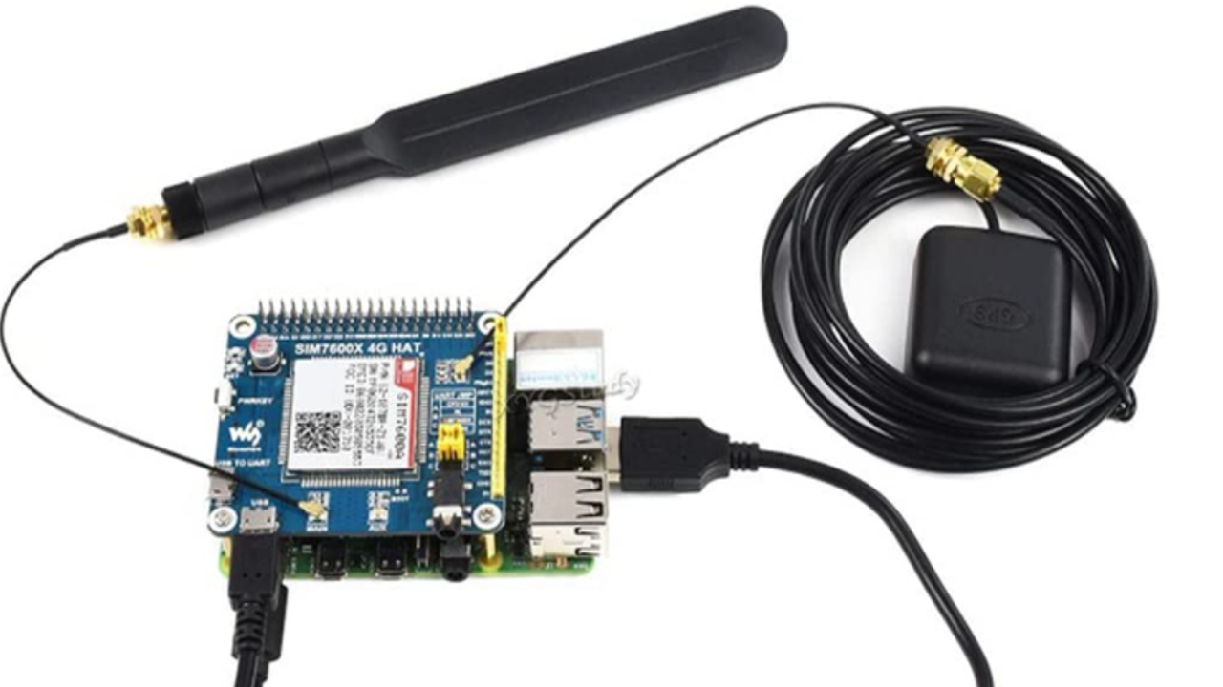

* Fig.4.12 GSM MODULE
* •Short message service (SMS)
* •The security strategies standardized for the GSM system make it the most secure telecommunications standard currently accessible. Although the confidentiality of a call and secrecy of the GSM subscriber is just ensured on the radio channel, this is a major step in achieving end-to-end security
* •The features of the GSM module include the following.
* •Improved spectrum efficiency
* •International roaming
* •Compatibility with integrated services digital network (ISDN)
* •Support for new services.
* •SIM phonebook management
* •Fixed dialing number (FDN)
* •Real-time clock with alarm management
* •High-quality speech
* •Uses encryption to make phone calls more secure

**GPS MODULE**

GPS modules contain tiny processors and antennas that directly receive data sent by satellites through dedicated RF frequencies. From there, it'll receive timestamps from each visible satellite, along with other pieces of data.

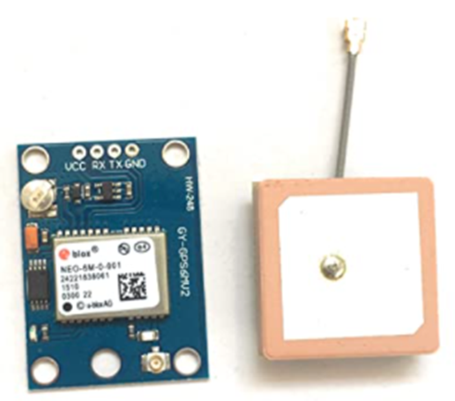

* Fig.4.13 GPS MODULE
* **Specifications :-**
* •NEO-6M V2 GPS Module EEPROM Built-in Active Antenna APM2.5 APM2.0
* •With ceramic antenna ensures strong signal With data backup battery
* •With power down data storing EEPROM
* •Compatible with various flight-control modules
* •LED signal indicator

**EasyEDA Software**

To demonstrate the process, we use an online service called [EasyEDA](https://easyeda.com/) to design a PCB layout.

This online software is easy to use and the rates are very affordable. Following are the specifications of the EasyEDA software:

* project folder: shows all the created projects.
* Design manager: information about all the placed components and wiring details.
* Easyeda library (EELib): can find all the general components like gnd, Vcc, resistor, capacitor, diode, led etc.
* General library: can find all the remaining components from LCSC and user contribution. It shows the component symbol, its footprint and its real image.
* File menu: we can create new schematic, PCB design etc. Also can open the circuit using other softwares like kicad, Orcad etc.
* Location menu: we can find all the components, wiring pins etc. and place them on the circuit.
* PCB menu: after creating the schematic, we can convert it to PCB. A new window will open where we can design the new PCB.
* Setting menu: for some general settings and simulation process.
* Export BOM menu: can export all the list of components which we have used with their model number and purchasing list.
* Appearance menu: we can change the theme and background of the workplace.

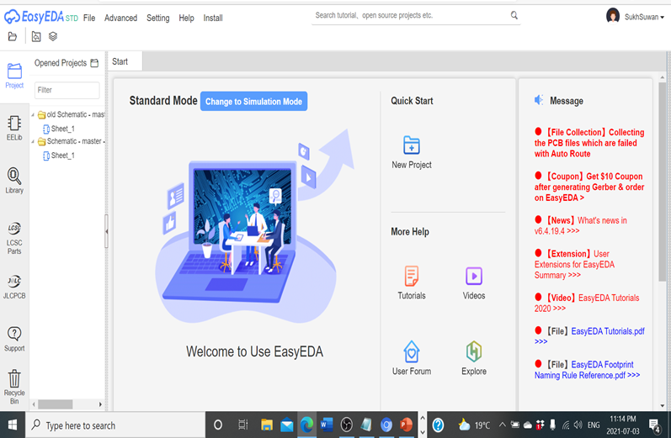

Fig.4.14 EasyEDA Software

**PCB**

It Stands for "Printed Circuit Board and it is a thin board made of fiberglass, composite epoxy, or other laminate material. It is used to solder all the components on the PCB, such as transistors, resistors, and integrated circuits.It can be single-sided, double-sided or multilayer.

PCBs are often associated with computers, they are used in many other electronic devices.

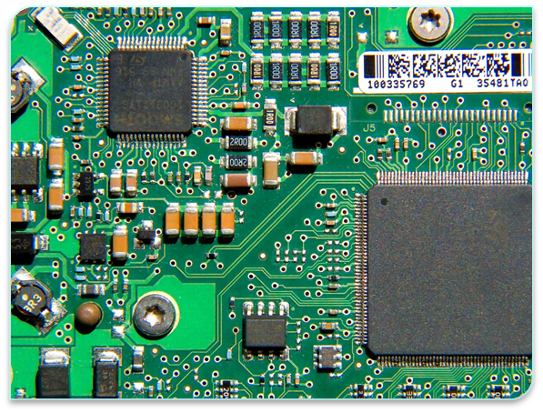

Fig. 4.15 what PCB look like

In this we used the thru-hole mounting technique. In the [thru-hole mounting process,](https://emsginc.com/services/thru-hole/)the assembler places component leads into holes drilled into a bare PCB. Thru-hole technology creates a stronger connection than surface mount technology does, so it’s used for applications that require high reliability.

**Creating The Schematic**

To design our device, first of all we need to create the schematic. For this purpose, we have used EasyEDA which is an online platform to design schematics.

we have followed the below-mentioned steps:

* Go to File Menu, then click on New. There you can either create a project first then a schematic or just click on the schematic.
* Then you’ll see a blank canvas where you can draw the schematic:
* Place all your schematic symbols on the canvas before drawing any wires.
* Schematic symbols are located in “Libraries”. The EELib has common symbols.
* There are also “User Generated Libraries” with lots of other symbols.
* Start drawing the wires using the wiring tool on the top right corner.
* Also, label all the components, The labels will be transferred over to the PCB layout and eventually be printed on the finished PCB.

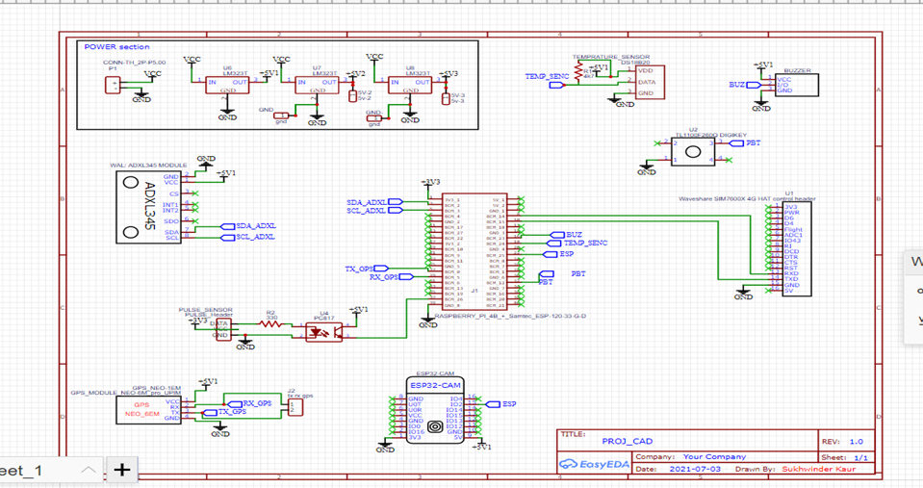

Figure 4.16 schematic design

Furthermore, if a PCB is used in the device we can generate the PCB design from the schematic, that option is available in the same platform.

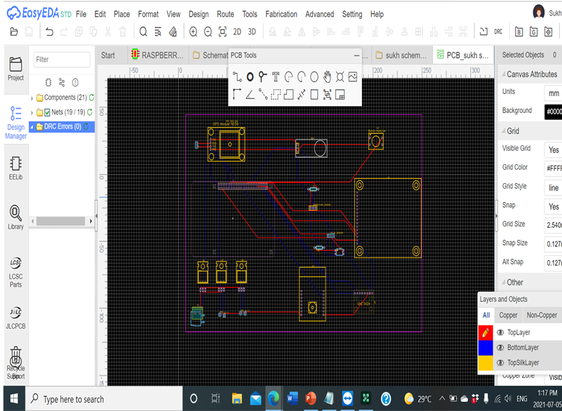

Figure 4.17 PCB Layout Design

**Gerber File**

Gerber files are ASCII vector files in which each physical board layer of your PCB design is described. Copper traces, vias, pads, solder masks, and silkscreen images are all represented on a circuit board by a flash or draw code and described by a set of vector coordinates.

* We can also download your PCB’s Gerber files if you want to send them to a different manufacturer.
* Gerber files are a set of image files that contain the patterns used to manufacture your PCB.
* All of the files are compressed into a single .zip file. There is a separate file for the copper traces, silkscreen, and locations of drill holes and vias

After making the Gerber File, we will send this file to the manufacturer to get the PCB required for the project.

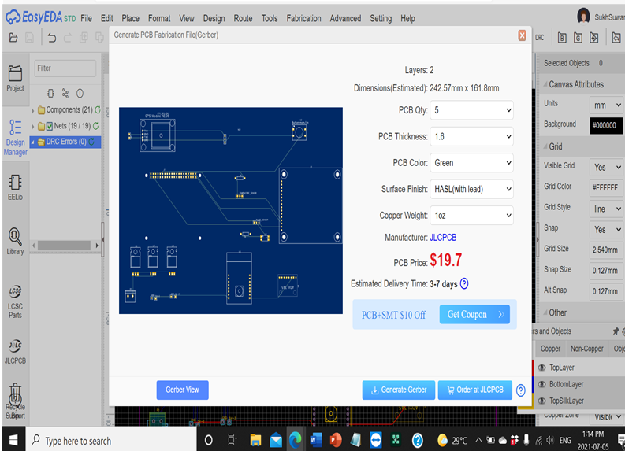

Figure 4.18 PCB Fabrication File

**Chapter V**

**Implementation and Test**

**Flow Chart** 

Flow chart helps to make the picture more clear, it tells about the features we need in our device so that it can run smoothly, and we conclude all the possibilities. The probability of all the cases is carefully observed and concluded.

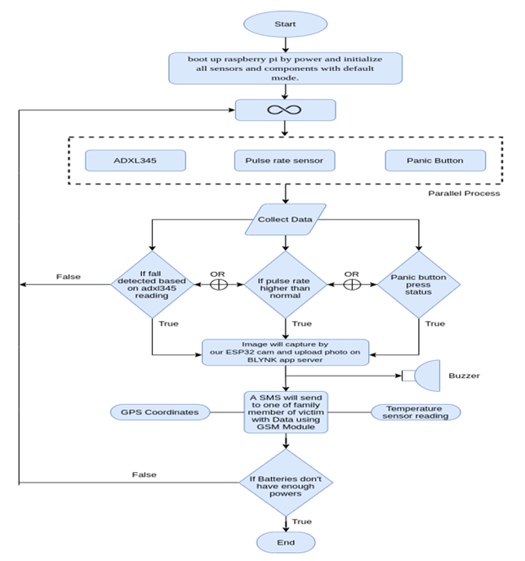

Fig. 5.1 Flow chart of Fall Detection and Monitoring system

Before integrating and testing the final product we have tested out every component to be sure the individual components work properly for example:

**RASPBERRY PI 4** 

Raspberry Pi is a small-sized computer that uses the Linux operating system. It is a mini-size computer used mostly to run larger and smart programs to achieve output quickly. Raspberry Pi 4 B+ (RP4) is the latest model developed by the company, which has all the required latest wired and wireless communications systems used in most This project aims, Arduino UNO smart projects. A single Raspberry Pi 4 comes to a Quad-Core processor but it has three different versions which give three different sizes of RAM. Pi 4 uses mini HDMI and it also has two ports for two 4K displays.

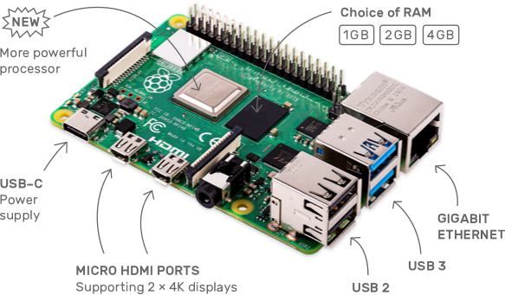

Fig. 5.2 Raspberry Pi

Step 1: Setting up your Raspberry Pi computer

* Preparing your SD card
* Raspberry Pi hardware and set-up
* Setting up Raspbian

Step 2: Preparing your SD:

* Download and launch the Raspberry Pi Imager from<https://www.raspberrypi.org/software/>
* Select the OS and SD card to install the files.
* Click on Write to start the process.
* Once completed we can eject the SD card

Step 3: Setting Up Hardware:

* Connect the power source to the Raspberry Pi's power port by plugging it into a socket.
* The Raspberry Pi's red LED signifies that the device is powered up and yellow indicates it is booting up.
* The Raspberry Pi OS desktop will appear after a few seconds of booting.
* The Welcome to Raspberry Pi software will appear and walk you through the setup process.

**Using Raspberry Pi:-**

* Raspberry Pi runs Raspbian OS, which is a distribution of Linux OS.
* Text Editor: On the top left section of the start-up window, click on Accessories>> Text editor.
* Keyboard and mouse settings: Select Preferences>>Mouse and Keyboard Settings (From here we can adjust the speed of the mouse or delay between the values.

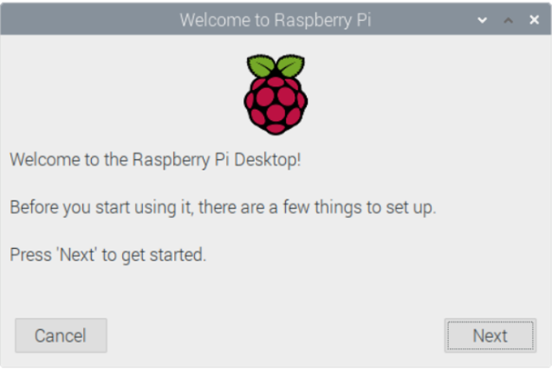

Fig. 5.3 Raspbian Set Up

* Next, select country, language, and timezone, then click Next yet again.
* Now, Set the password for the Raspberry Pi.
* Connect to your wifi by selecting your wifi and enter its password.
* At Last, restart the device and Raspbian will boot up.

**Raspberry Pi Testing with LED:**

Components required: Breadboard, Raspberry Pi, Header Pin cables, resistors, and LED

Make connections as shown in fig:

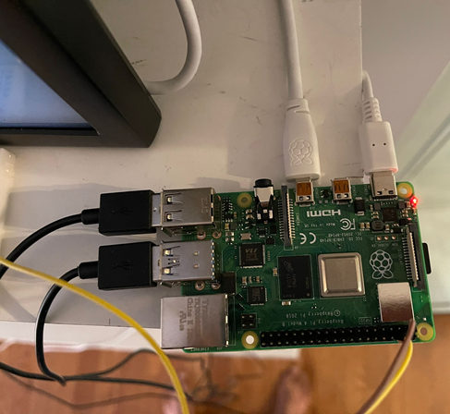

Fig. 5.4 Hardware connections to test RPI

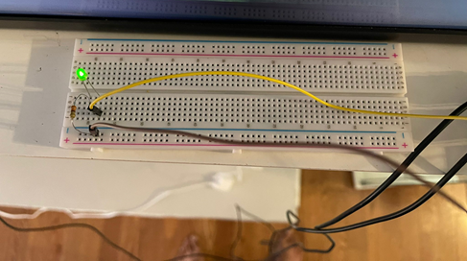

Fig. 5.5 Breadboard connections for testing

Steps:

•Open Terminal and write these commands:

•cd /sys/class/gpio

•echo "2" > export

•cd gpio2

•echo "out" > direction

•echo 1 > value

•echo 0 > value

First C PROGRAM:

•Step 1: Making a directory

•Locate a directory: cd

•First make a directory using the command: mkdir programs

•Change directory: cd programs

**Step 2: Writing program**

**Create source code using nano editor:** nano helloworld.c

**Write your code**

| #include<stdio.h> int main() {  printf("Hello World\n"); } |
| --- |

**Press ctrl + x to exit the editor, then y and enter**

**Step 3: COMPILING THE PROGRAM**

•We will compile the program into a new file called myfirstprogram: gcc hello-world.c -o myfirstcprogram

•Making the file executable chmod +x myfirstcprogram

•Executing the program: ./myfirstcprogram

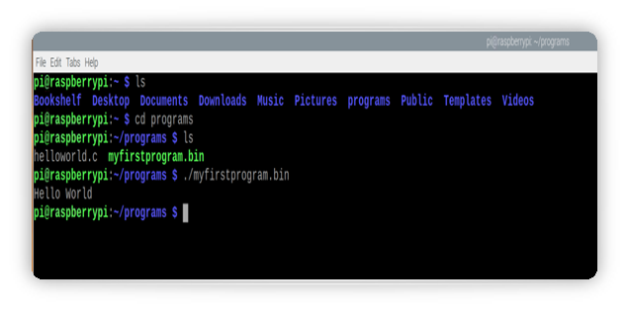

Fig. 5.6 Terminal commands for testing

We have successfully tested the raspberry pi.

**Code Interfacing:**

**Testing of Panic Button**

**Proteus:**

The Proteus Design Set is a proprietary software tool suite that is primarily used for automation of electronic design. Electronic design experts and technicians use the software to develop schematics and electronic prints for printed circuit board manufacture.

**Installation:**

* Download Proteus from the link <https://www.labcenter.com/downloads/>
* Click on New project
* Add the components from the left side by selecting P.
* Place the components and change the values according to the requirement.

**Active High config pull up circuit**

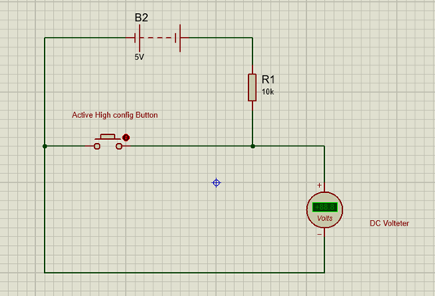

Fig. 5.7 Active High Pull Up Circuit

**LOGIC 1 when button not pressed**

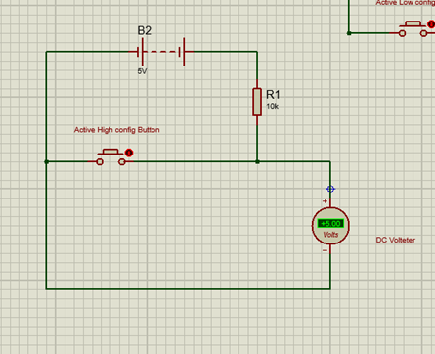

Fig. 5.8 Active High Pull Up Circuit

**Push Button Testing With Raspberry Pi**

* Make connections as shown in fig 5.9.
* In my project I am using gpio pin 2.

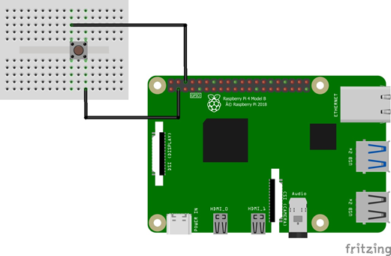

Fig. 5.9 Testing Panic Button with Raspberry Pi

**Steps:**

* Open geany from the top left section of start up menu
* Menu>>Programming>> Geany
* Write a C code

**Code:**

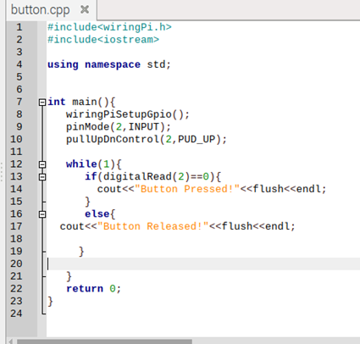

Fig. 5.10 C++ Code For Testing Panic Button with Raspberry Pi

Now it’s time to set up all the connections according to the below-shown figure:

**Interfacing of BUZZER with RASPBERRY PI4:-**

| #include<wiringPi.h> #include<iostream> using namespace std; int main(){  wiringPiSetupGpio();  pinMode(2,OUTPUT);  cout<<"Buzzer ON!"<<flush<<endl; digitalWrite(2, LOW);  delay(2000);    cout<<"Buzzer OFF!"<<flush<<endl;  digitalWrite (2, HIGH);  delay(2000);  return 0; } |
| --- |

**Pins used in interfacing:-**

**Rasp Pi4< buzzer**

1 PIN Vcc < Vcc 3.3V

3 PIN GPIO2<I/O

6 PIN GND<GND

**Interfacing of RASPBERRY PI4 with GPS :-**

**Source Code:-**

| void myGPSEvent(Uart *object){  int count=0;   string loc[4]; // String array with size 4  char *arr; // character pointer   string data, extracted_data="";  while(1){  ++count;  data=object->gpsRead(); // data read and store into variable.   extracted_data+=data; // character into extracted+data   if(count>2){  break;  }  }  data="";  cout<<extracted_data<<endl;  for(int i=19; i<strlen(extracted_data.c_str()); i++){  /* filter data to slice string to desired format */  data+=extracted_data[i];  }  count=0;  for(int i=0; i<4; i++) //initially all array index set to ""  loc[i]="";    for(int i=0; i<strlen(data.c_str()); i++){ /*   filter data and store coordinates and direction to array  * */  if(data[i] ==','){  count++;  }  else{  loc[count]+=data[i];  }  if(count>4){  break;  }  }    for(int i=0; i<4; i++){ // convert index value according to direction  if(loc[i]=="N"){  loc[i]="1";  }  else if(loc[i]=="W"){  loc[i]="-1";  }  else if(loc[i]=="S"){  loc[i]="-1";  }  else if(loc[i]=="E"){  loc[i]="1";  }  }      latitude=object->raw_data_to_coord(loc[0]) * atoi(loc[1].c_str());   /* Latitude -- coming from function */  longitude=object->raw_data_to_coord(loc[2]) * atoi(loc[3].c_str());   /* Longitude -- coming from function */    /* atoi ---> convert string to int */    printf("\nLatitude: %lf\nLongtitude: %lf\n\n",latitude,longitude); } |
| --- |

**Pins used for GPS to interface with RASPBERRY PI4:-**

Rasp Pi4< GPS

2nd PIN For voltage < Vcc (5V)

6th PIN is the GND< GND

29th PIN for Receiving the data < TX

**Interfacing PULSE RATE SENSOR with RASPBERRY PI4 :-**

**Source Code :-**

| #include <wiringPi.h> #include <wiringSerial.h> #include <unistd.h> #include <iostream> #include <stdio.h> #include <sstream> #include <string> #include <errno.h> #include <cstring> using namespace std; string ARDUINO="/dev/ttyACM0"; char dat; string BPM=""; void pulseRateEvent(int serial_port){  BPM="";  for(int i=0; i<3; i++){  if(serialDataAvail (serial_port))  {  dat = serialGetchar (serial_port); /* receive character serially*/   BPM+=to_string(int(dat)-48);  fflush(stdin);  } } if(strlen(BPM.c_str())>1) cout<<" [ BPM: "<<BPM<<" ]"<<endl; } int main(){  int serial_port ;  if ((serial_port = serialOpen (ARDUINO.c_str(), 9600)) < 0) /* open serial port */{  fprintf (stderr, "Unable to open serial device: %s\n", strerror (errno)) ;  return 1 ;  }    if (wiringPiSetup () == -1) /* initializes wiringPi setup */  {  fprintf (stdout, "Unable to start wiringPi: %s\n", strerror (errno)) ;  return 1 ; } while(1){  pulseRateEvent(serial_port);  system("sleep 0.2");  fflush(stdout); }  return 0; } |
| --- |

**PINS USED IN INTERFACING :-**

Pin-1 (GND): Yellow Color Wire – It is connected to the GND terminal of the system.

Pin-2 (VCC): Orange Color Wire – It is connected to the supply voltage ( +5V otherwise +3.3V) of the system.

Pin-3 (Signal): Red Color Wire – It is connected to the pulsating o/p signal.

**Interfacing ADXL 345 with Raspberry pi 4 :-**

**Source Code :-**

| #include <iostream> #include <unistd.h> #include <wiringPiI2C.h>  using namespace std;  int main() {  int fd;    fd = wiringPiI2CSetup(0x53);   cout << "Device Status: "<< fd << endl;  char buf[6] = {0};  int x,y,z;  while(1)  {  buf[0] = wiringPiI2CReadReg8(fd, 0x32);  buf[1] = wiringPiI2CReadReg8(fd, 0x33);   buf[2] = wiringPiI2CReadReg8 (fd, 0x34);  buf[3] = wiringPiI2CReadReg8(fd, 0x35);   buf[4] = wiringPiI2CReadReg8 (fd, 0x36);  buf[5] = wiringPiI2CReadReg8(fd, 0x37);   x = ((int)buf[1]<<8) | (int) buf[0];   y = ((int)buf[3]<<8) | (int) buf[2];  z = ((int)buf[5]<<8) | (int) buf[4];    cout<<"x:"<<x<<"\ty:"<<y<<"\tz:"<<z<<endl;  sleep(1);  }    return 0; } |
| --- |

**Initially, the Raspberry pi window appears and after making connections.**

**The following command will be used :**

| gpio i2cdetect Result would be the address of the ADXL module cd Desktop g++ ad.cpp -lwiringPi ./a.out |
| --- |

**Interfacing of ESP32 CAM WITH RASPBERRY PI 4:-**

**Connection of Raspberry pi 4 with ESP 32 CAM**

GPIO 22 Of raspberry pi 4- ESP IO14

5V -5V

GND - GND

GPIO 37 to IO15

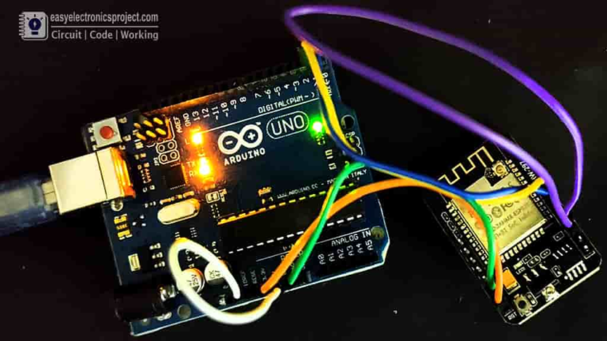

Fig 5.11 ESP32 with RASPBERRY PI

**Source Code**

| #include <wiringPi.h> #include <iostream> #include <string> #include <cstring>   // Macro definition #define IN "ip" #define OUT "op" #define PULL_UP "pu" #define PULL_DOWN "pd"   using namespace std;   void setMode(int pin_num, string md, string logic="pd"){ string command; if(md==OUT){ command="raspi-gpio set "+to_string(pin_num)+" "+md; }else{ command="raspi-gpio set "+to_string(pin_num)+" "+md+" "+logic; } system(command.c_str()); }   int main(){ //IDE --> Integrated Development Environment wiringPiSetupGpio(); setMode(25,OUT);  while(1){ digitalWrite(25, HIGH); delay(1000); digitalWrite(25, LOW); delay(3000); } return 0; } |
| --- |

**Terminal Commands :-**

| pi@raspberrypi:~/Desktop $ pinout pi@raspberrypi:~/Desktop $ g++ espInterfacing.cpp -lwiringPi pi@raspberrypi:~/Desktop $ ./a.out pi@raspberrypi:~/Desktop $ raspi-gpio help |
| --- |

**Interfacing Temperature Sensor with Raspberry pi**

After testing we have interfaced the temperature sensor with Raspberry pi. Using 3 pins VCC, Ground, Data.

| #include <iostream> * This library does contain input output logic or function definition for cin and cout keywords.**/  #include <string> *This library does contains string related functions*/  #include "DS18B20.h" *This library does contain functions and classes for our Temperature sensor*/  using namespace std; // This is a namespace package for using standard input output functions.  Int main() { // MAin function or compiler entry point. double tempNow; // this is a double type variable declaration. bool status=0; char wi_addressf[16]= "28-9120267e7e7c": // this is a char array of size 16 which does contain the address of the temperature sensor. int chce; cout << "The address you entered was " << w1_address << endl; // Print output DS18B20 w1Device1 (w1_address); while(1){ cout<<"Choose any one "<<endl<<endl; cout<<"1. Temperature in celsius"<<endl; cout<<"2. Temperature in Fahrenheit"<<endl; cout<<"3. Exit"<<endl<<endl; cout<<"Enter Choice : "; cin>>chce; switch(chce) { case 1: w1Device1.setUnits(0); status=0; break; case 2: w1Device1.setUnits(1); status=1; break; case 3: exit(0); break; default: cout<<"Invalid Option" <<endl<<"###############"<<endl; } tempNow = w1Device1.getTemp(); if(!status){ cout << "The current temperature is " << tempNow << " degrees Celsius" <<endl<<endl; else{ cout << "The current temperature is " << tempNow << " F" <<end1l<<"############"<<endl; } } return 0; } |
| --- |

**Raspberry Pi4 interfacing with Pulse rate sensor using Arduino over UART**

After testing we have interfaced the temperature sensor with Raspberry pi. Using 3 pins VCC, Ground, Data.

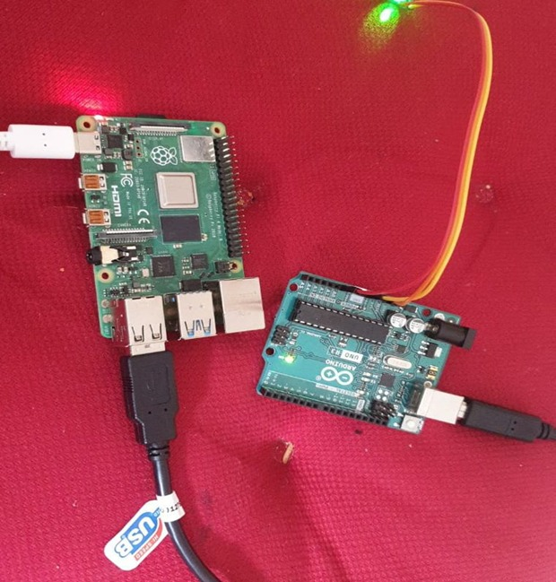

Fig. 5.12 wiring of Pulse Rate Sensor with Raspberry Pi4 using Arduino

**Raspberry Pi4 interfacing with GSM**

•Open Geanny>> write the program >> save the program with .cpp file extension >> open terminal >> compile the file >> execute the file

**CODE:**

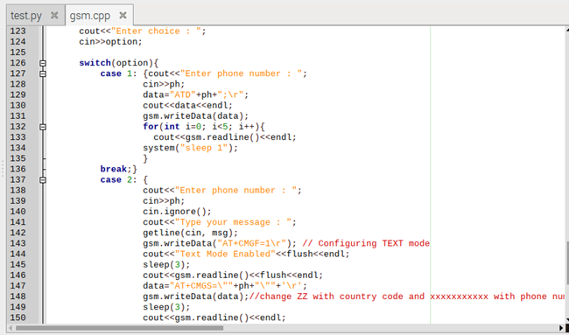

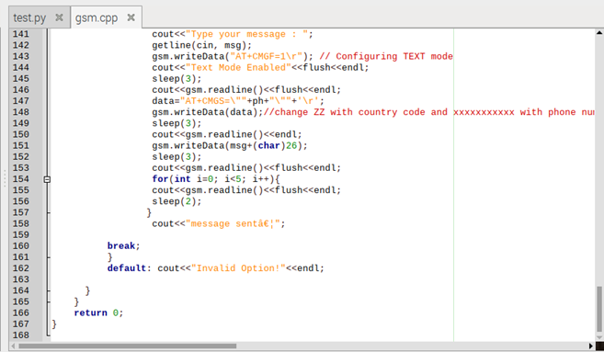

Fig. 5.13 Code for GSM

**Code Integration**

After testing and interfacing all the components with Raspberry pi, we came up with a combined code for the desired working of the system. The code was successfully integrated and gave us the required output. The main code is as below and there is a link for the full program to make it more clear.

| int main(){  fd = wiringPiI2CSetup(0x53);  int serial_port ;  char dat;  if ((serial_port = serialOpen (arduino.c_str(), 9600)) < 0) /* open serial port */  {  fprintf (stderr, "Unable to open serial device: %s\n", strerror (errno)) ;  return 1 ;  }  if (wiringPiSetup () == -1) /* initializes wiringPi setup */  {  fprintf (stdout, "Unable to start wiringPi: %s\n", strerror (errno)) ;  return 1 ;  }  Uart gsm(gsm_addr,B115200);  Uart pulse(arduino,B9600);  wiringPiSetupGpio();  setMode(BUZZER,OUT);  setMode(PANIC_BUTTON,IN,PULL_UP);  digitalWrite(BUZZER,HIGH); |
| --- |



Fig. 5.14 Raspberry Pi4 header pin connections with all components

**Link for Code Integration:**

<https://github.com/navjotsb/CapstoneProject_G4/blob/main/code%20integration%20final>

After the integration of our code, we have tested our product in different locations and situations to check the dependability and accuracy of the product.

**Sample Message:**

Oldsters need help!

BPM:220

Temp: 22 C

Image: https://65dd5b609aa4.ngrok.io/capture?_cb=1234

Location: <https://maps.google.com/?ll=43.700114,-79.761258>

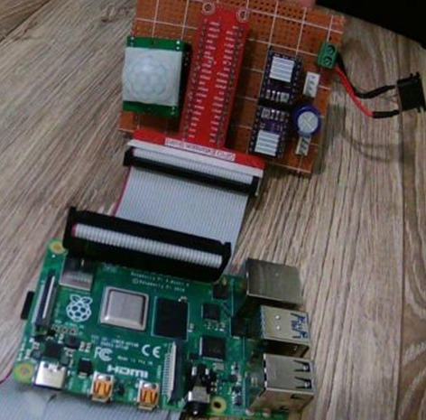

Fig. 5.15 Execution of Code

Our device is tested and found working as intended.

**Plug and Play:**

To fulfill this functionality, we have made sure that there is no need for any external source such as a personal computer to boot up the system. The whole program is saved in the microcontroller and it will automatically boot up on powering on.

Follow the below mentioned steps as well:

1. Attach all the components to Raspberry pi4.
2. Make sure the components are well soldered.
3. Use the Multimeter to check the continuity of the circuit.
4. Place all the components on the belt and secure them.
5. Place pulse rate sensor and temperature sensor carefully for accurate values.
6. Now we can power up the circuit.
7. Then the person can press the panic button to get the message on the care taker’s mobile to test the device.

**Chapter VI**

**Evaluation**

**Introduction**

This chapter explains solutions as per the user requirement. It will analyze testing methods used during development. Finally, the chapter will go on to discuss methods of solving issues of the Raspberry pi, ADXL 345, AND ESP CAM 32, and many more. We fixed these issues. This chapter will include all solutions provided by all of us and the internet.

**Minimum Requirements**

Minimum product output will be a belt on which Raspbian OS is running which can help to capture images through ESP 32 CAM, get navigation through GPS and GSM module, illustrate temperature and BPM of the wearer as well. Belt size will depend on the user. All things need to be well placed on the belt.

**Troubleshooting**

This section will be related mostly to the conversation of the team and practice about solving some issues. As different components are having distinct power requirements so two types of regulators are used(LM323 AND 78S05). One of the other solutions is to use Arduino Uno to load the code over different components to keep these in the running and functional stage.

“When We run ADXL with Raspberry pi 4 it runs fine, but when We connect ESP 32 CAM and pulse rate sensor together with Raspberry pi 4, it runs fine but, temperature sensor stops working. We assume that it’s due to loose connections between MCU and temperature sensor OR due to faulty components. We made connections properly by checking the power supply. Ultimately, the result has been driven.

While interfacing Raspberry Pi 4 with ESP 32 CAM, it became so hard to lose the code over ESP CAM 32 through Arduino Uno. After a deep scruinty, we found that an issue was there with regard to time-out to press the reset button in order to load source code over ESP 32 CAM through Arduino Uno. So, after doing a lot of practice, I made a time-in which means there was a press of the reset button at a proper time.

We have faced some issues with Real-time operation as it was hard to give priority. After all the efforts from our class discussion and internet surfing. We came across a site named Oracle and used their articles to solve this issue.

We have given priority to components according to our requirement and used two header files to solve this issue, the libraries are Scheduling and pthread.

#include <sched.h> // Scheduling library for prioritization of threads

#include <pthread.h> //provide the POSIX thread(pthread) standard API(Application program Interface) for all thread related functions

Following is the code I have used to sort it:

<https://github.com/navjotsb/CapstoneProject_G4/blob/main/Veerpal%204th%20IM%20Final%20Code>

**Chapter VII**

**Conclusion**

The aim of this project is to develop a product that can efficiently and timely notify about the fall which can help oldsters and their family members from many fatal consequences. Our goal is to provide the aged people a sense of security that they have something with them which can help them if they could not do anything. The development is focused on portability and performance.

In development, we found that we need an Arduino UNO to program a pulse rate sensor which adds one more component and makes the project larger. Although all the minimum user requirements are met, the product is completed and the user is still restricted to use it with little care. Also, users need to set up a BLYNK App which might be difficult for some people.

This product development can be extended to improvements like if we do not use Arduino UNO and can directly program pulse rate sensors. It will reduce both size and weight. There can be an alternative to replace the setup of the BLYNK app for the user.

**Future Work**

We will try to resolve these issues which are stated above to make the device more efficient and convenient. More research and knowledge are needed to solve these problems so that we can take it one more step ahead and make a better version of it. We need to work on the below-mentioned areas to even make them more useful.

1. The number of processors can be reduced so that we can use it with the same functionality, but the size would be smaller.
2. We need to work on the alert system as now we are using the BLYNK App or make more easy setup for users.
3. We want the system not to shut down because of power so we want to give some backup or more power.

**Chapter VIII**

**User’s Guide**

**Powering Up**

Step 1- Connect the Batteries Holder with the system. There are two wires, one is Red and another one is Black. Connect Red with VCC and Black with Ground.

Step 2 - Wear the Belt properly, making sure no wires or devices are displaced.

Step 3- Adjust the pulse rate sensor on the proper finger and make it secure.

Step 3- Make sure the temperature sensor is connected to your body such as your stomach or underarm wherever you feel more comfortable. Avoid attaching it above clothes.

Step 4- Power up the system now, turn it on. It is ready to use.

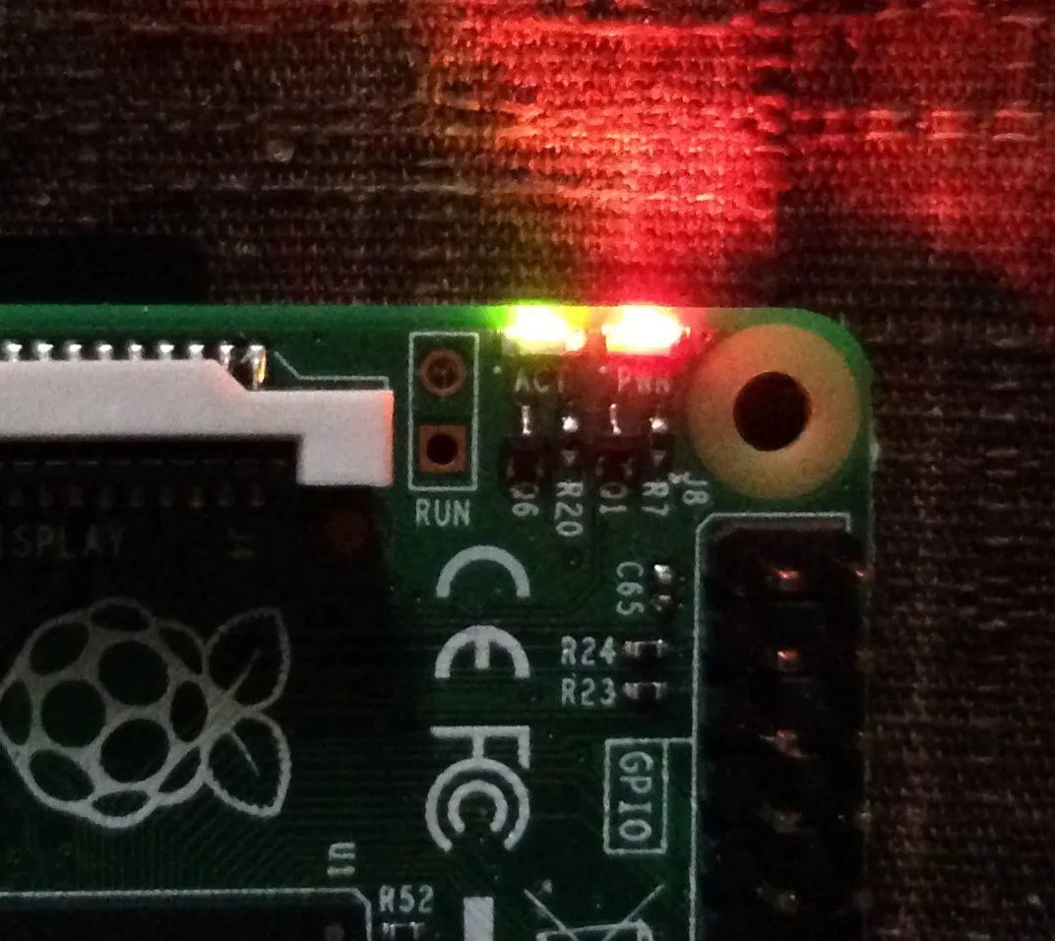

Fig. 8.1 Raspberry Pi4 powered up

Step 5- Download BLYNK App from your mac, window, or Android store. Login to BLYNK App with the id password given.

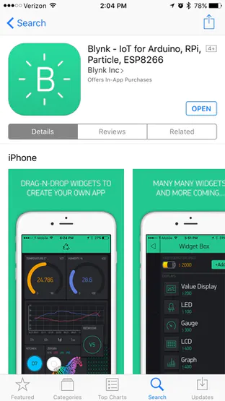

Fig. 8.2 Blynk App installation from App store

Step 6: Connect your system with the mobile hotspot. When you turn on a hotspot it will automatically connect.

**Instructions -**

1. Keep the battery in good shape with best charging practices. The user should take care of the battery life of the device. The battery life is sufficient for continuous use up to 6 hours. and after that, the user can recharge the batteries/cells with the provided rechargeable holder/Smart charger.
2. There is a button on the system. To inform you this button makes a loud noise when you press it, so not just for fall, whenever you feel it is hard to speak or in any other emergency, press this button. The noise is loud enough to listen within at least 10 meters.

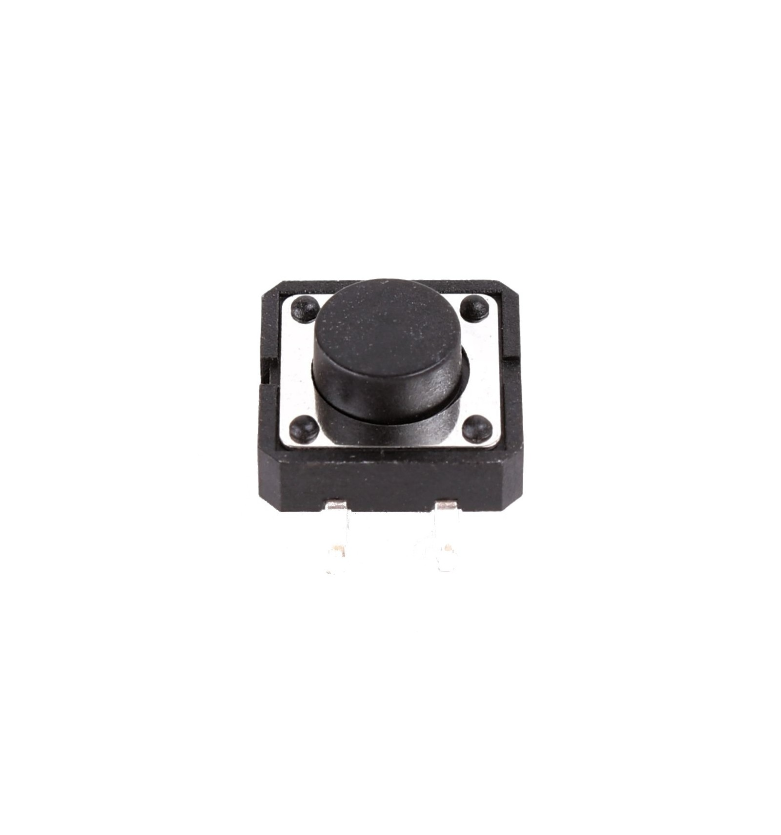

Fig. 8.3 Panic Button on the device

1. Remove the belt carefully when not in use. Make sure you don't displace any components.
2. Please do not drop or crush your device. This will void your warranty.
3. Your device is sensitive to liquids and humidity.
   1. Please keep the device away from sinks.
   2. Do not use the device outdoors during wet weather like snow or rain, or indoors in a very humid environment (for example, in a kitchen's dishwasher area, a sauna, or inside a greenhouse).
   3. Keep drinks a safe distance away.
   4. Please do not submerge your device (for example, put it in the sink or dishwasher) for any reason.
   5. Please do not drop or crush your device. This will void your warranty.
4. There are no user-replaceable parts inside your device. Please don't try to open it. This will void your warranty.
   1. Opening your device can cause it to permanently stop working.
   2. If your device is not working, contact our customer care for help.

**Instructions for the caretaker:** Please save the device calling number as an Emergency number. You are receiving any calls or messages only in case of emergency, so pay attention to them.

**Chapter IX**

**References**

1. DROK. (2014, July 2). *AMAZON*. DROK DS18B20 Temperature Sensor Digital Temp Probe Waterproof Thermal Cable Stainless Steel Probe 3 Meter Thermometer Gauge Thermistor Detector Sensor Indoor Outdoor Lab Car Usage. https://www.amazon.ca/gp/product/B00KLZQ0P8/ref=ox_sc_act_title_3?smid=AFHAE9RJVUMB&psc=1
2. Generic. (2016, March 2). *AMAZON*. Heart Rate Pulse Sensor Sensor Module For Arduino. https://www.amazon.ca/gp/product/B01CFGOZM0/ref=ox_sc_act_title_13?smid=AVNUMXY5HN76V&psc=1
3. ‎NL International Co., Limited. (2019, Sep 18). *AMAZON*. NEO-6M GPS Module with Antenna NEO6MV2 EEPROM APM2.5 & Antenna for MWC/AeroQuad for Flight Control Aircraft Arduino. https://www.amazon.ca/gp/product/B07Y2PDVG8/ref=ppx_yo_dt_b_asin_title_o03_s00?ie=UTF8&psc=1
4. Ocr. (2016, Dec 15). *Amazon*. Ocr 10Value 180PCS Tactile Push Button Switch Micro Momentary Tact Assortment Kit. https://www.amazon.ca/gp/product/B01NAJEVE3/ref=ppx_yo_dt_b_asin_title_o06_s00?ie=UTF8&psc=1
5. Oiyagai. (2018, Jan 2). *AMAZON*. Oiyagai 5pcs DC 3.3-5V Passive Low Level Trigger Buzzer Alarm Sound Module for Arduino. https://www.amazon.ca/gp/product/B0777P6FN5/ref=ox_sc_act_title_10?smid=AVKVKSQRPUCTR&psc=1
6. POWXS. (2020, Dec 11). *AMAZON*. POWXS 18650 Battery Charger 4 Bay LCD 18650 Charger for 18650 26650 22650 21700 20700 18490 18350 17670 17500 16340(RCR123) 14500 Li-ion Rechargeable Batteries and C AAA AA Batteries Rechargeable NiMH NiCD. https://www.amazon.ca/gp/product/B08KVTNL28/ref=ox_sc_act_title_2?smid=A2BZG7SAULJS8P&psc=1
7. ‎Raspberry Pi. (2019, July 11). *AMAZON*. Raspberry Pi 4 Model B 2019 Quad Core 64 Bit WiFi Bluetooth (4GB). https://www.amazon.ca/gp/product/B07TC2BK1X/ref=ppx_yo_dt_b_asin_title_o09_s00?ie=UTF8&psc=1
8. RGBZONE. (2021, jan 25). *AMAZON*. RGBZONE 120pcs Multicolored Dupont Wire 40pin Male to Female, 40pin Male to Male, 40pin Female to Female Breadboard Jumper Wires Ribbon Cables Kit for Arduino and Raspberry Pi. https://www.amazon.ca/gp/product/B08TWSV2DY/ref=ox_sc_act_title_6?smid=A2ATRTUSTEVBNS&psc=1
9. Sandisk. (2015, july 31). *AMAZON*. SanDisk Ultra 64GB microSDXC UHS-I Card with Adapter, Grey/Red, Standard Packaging (SDSQUNC-064G-GN6MA). https://www.amazon.ca/dp/B010Q588D4/ref=cm_sw_r_wa_api_glt_i_P3VKHEGS3XAG17DF10G1?_encoding=UTF8&psc=1
10. sara-u. (2021, April 30). *AMAZON*. Sara-u ESP32-CAM WiFi Bluetooth Board ESP32-CAM-MB Micro USB To Serial Port CH340G with OV2640 2MP Camera Module Dual Mode Compatible for Ardui No. https://www.amazon.ca/gp/product/B093WCNN73/ref=ox_sc_act_title_11?smid=A21SOX52O4K4YS&psc=1
11. TABIGER. (2020, sep 12). *AMAZON*. Soldering Iron Kit Welding Tool, Soldering Kit with LCD Digital Multimeter, 60W Soldering Iron with 5 Extra Tips, Stand, Desoldering Pump, Solder, Wire Stripper Cutter, Tweezers, Tape, Tool Bag. https://www.amazon.ca/gp/product/B08GWN1ZCZ/ref=ox_sc_act_title_4?smid=A1K2855SQRH0DK&th=1
12. ‎UNIVERSAL-SOLDER. (2019, Feb 12). *AMAZON*. ADXL345 3-Axis Digital Accelerometer Module, I2C Interface. https://www.amazon.ca/gp/product/B07GD9L8BC/ref=ox_sc_act_title_17?smid=A29AOP4GIE7DX6&psc=1
13. ‎XYG-Raspberry Pi. (2019, March 21). *AMAZON*. 4G 3G GNSS HAT Based on SIM7600A-H LTE CAT4 150Mbps Wireless Communication Telephone Call SMS Compatible with Raspberry Pi 4 3 2 Model B B+ Zero W WH (US CA)@XYGStudy. https://www.amazon.ca/gp/product/B07PSGKWT5/ref=ppx_yo_dt_b_asin_title_o08_s00?ie=UTF8&psc=1
14. Yosawa. (2019, march 15). *AMAZON*. Yosawa 2 x 3.7V（ 7.4V ）18650 Battery Holder Case,4 Pack 2 Slots x 3.7V DIY Battery Storage Box with Red and Black Wire Leads. <https://www.amazon.ca/Yosawa-%EF%BC%8918650-Battery-Holder-Storage/dp/B07M5CTFST/ref=mp_s_a_1_2_sspa?dchild=1&keywords=18650+battery+holder&qid=1622988776&sr=8-2-spons&psc=1&spLa=ZW5jcnlwdGVkUXVhbGlmaWVyPUEyUU9ETldQSEhWVThIJmVuY3J5cHRlZElkPUEwMTIxODUxT0o4N>
15. 15. Bought[Your Dollar Store With More Inc. | Your Dollar Store With More](https://www.dollarstore.ca/)
16. 16.Agnihotri, N. (2020, Sep 29). What are the different types of buzzers? Engineers Garage. <https://www.engineersgarage.com/buzzers-types-transducer-indicator-piezo-magnetic/>
17. 17. ESC, Q. (2020, Oct 27). What is a Buzzer? . <https://www.quisure.com/blog/faq/what-is-a-buzzer>
18. 18.HAREENDAN, T. K. (2007, july 7). NEO-6M GPS Module — An Introduction. ELECTRO SCHEMATICS. <https://www.electroschematics.com/neo-6m-gps-module/>
19. 19. MakeCrate, .. (2017, January 30). How does a buzzer work? . <https://www.makecrate.club/how-does-a-buzzer-work/71181/>
20. 20.Verma, A. (2007, July 7). *Cplusplus-Programming-Challenges*. Github. <https://github.com/skyv26/Cplusplus-Programming-Challenges>
21. 21.USING PRE-APRS (older) TNC FOR HOME OPERATIONS. (n.d.). *GPS - NMEA sentence information*.<http://aprs.gids.nl/nmea/>
22. 22.Howard, P. (n.d.). *Raspberry Pi Pinout*. UART - Universal Asynchronous Receiver/Transmitter. <https://pinout.xyz/pinout/uart>
23. .Oracle Corporation and/or its affiliates. (2010, Jan 7). *Oracle*. Thread Create Attributes. <https://docs.oracle.com/cd/E19455-01/806-5257/6je9h032j/index.html>
24. 24.htmlgeeksforgeeks.org. (2020, August 24). Multithreading in C++. geeks for geeks.<https://www.geeksforgeeks.org/multithreading-in-cpp/>
25. 25.Java T Point. (n.d.). C++ int to string javatpoint. <https://www.javatpoint.com/cpp-int-to-string>
26. 26.What is GPS, how GPS module is used for base station applications, how to choose GPS module ?,(2017, Oct <https://www.techplayon.com/gps-gps-module-used-base-station-applications-choose-gps-module/>
27. 27.Seeed the IOT Hardware enabler.(n.d.), GPS Modules Selection Guide<https://wiki.seeedstudio.com/GPS-Modules-Selection-Guide/>
28. 28.Elprocus.(n.d.),What is a GSM Technology : Architecture & Its Applications<https://www.elprocus.com/gsm-technology-architecture-its-applications/>
29. 29.SIM7600A-H GSM Module .(n.d.) Amazon Canada [4G 3G GNSS HAT Based on SIM7600A-H LTE CAT4 150Mbps Wireless Communication Telephone Call SMS Compatible with Raspberry Pi 4 3 2 Model B B+ Zero W WH (US CA)@XYGStudy: Amazon.ca: Electronics](https://www.amazon.ca/gp/product/B07PSGKWT5/ref=ppx_yo_dt_b_asin_title_o02_s00?ie=UTF8&psc=1)
30. GeeksforGeeks.(2018,Feb 8.),How GSM works ?<https://www.geeksforgeeks.org/how-gsm-works/>
31. .Electronics.Notes,(n.d.), System Overview of GSM<https://www.electronics-notes.com/articles/connectivity/2g-gsm/basics-introduction.php>
32. University of Kentucky.(n.d.), Global system for Mobile Communication(GSM)<http://www.uky.edu/~jclark/mas355/GSM.PDF>
33. Circuits Today.(n.d.), ESP32 Development Boards Review and Comparison<https://www.circuitstoday.com/gsm-and-gprs-module-price-guide>
34. .Makers. Advisor,(n.d.),ESP32 Development Boards Review and Comparison<https://makeradvisor.com/esp32-development-boards-review-comparison/>
35. Greengnu.(2019,Nov 7), How is it possible that ESP32 is so cheap?<https://www.esp32.com/viewtopic.php?t=13039>
36. .ESPRESSIF.(n.d.),ESP32<https://www.espressif.com/en/products/socs/esp32>
37. Teja.Ravi,(2021,Jan 15). How to Use a Multimeter? A Complete Beginner’s Guide to DMM [how to use a multimeter? a complete beginner’s guide (electronicshub.org)](https://www.electronicshub.org/how-to-use-a-multimeter/)
38. Github.(2021,June 16). Installation instructions using Arduino IDE Boards Manager [arduino-esp32/boards_manager.md at master · espressif/arduino-esp32 · GitHub](https://github.com/espressif/arduino-esp32/blob/master/docs/arduino-ide/boards_manager.md)
39. Arduino IDE Downloads,(n.d.), Downloads [Software | Arduino](https://www.arduino.cc/en/software)

40.Arduino IDE user guide,(n.d.), Guide [arduino_guide.pdf (reprapworld.com)](https://reprapworld.com/documentation/arduino_guide.pdf)

41.<https://easyeda.com/>

42.Hommer, H. (n.d.). *How to Use EasyEDA to design PCB Schematic Step By Step* WELLPCB.<https://www.wellpcb.com/easyeda.html>

43.vse, .. (2019, 10 29). *Gerber Files Explained: Understanding Their Role in PCB Manufacturing*. VSE. <https://www.vse.com/blog/2019/10/29/gerber-files-explained-understanding-their-role-in-pcb-manufacturing/>

44.Keim, R. (2020, 03 09). *Low-Pin-Count Serial Communication: Introduction to the 1-Wire Bus*. All about circuits. <https://www.allaboutcircuits.com/technical-articles/low-pin-count-serial-communication-introduction-to-the-1-wire-bus/>

45.RF wireless world. (n.d.). *1 wire protocol basics | Powering Modes,Signaling Modes*. Home of RF and Wireless Vendors and Resources. https://www.rfwireless-world.com/Tutorials/1-wire-protocol-basics.html

46.Todorov, G. (2015, 06 03). *DS18B20*. Github. <https://github.com/TeraHz/DS18B20>

47.Admin. (n.d.). *Understanding 1-wire interface*. ScienceProg. <https://scienceprog.com/understanding-1-wire-interface/>

48.]Raspberrypi.org. (2021). Retrieved (14 June 2021), from <https://www.raspberrypi.org/products/raspberry-pi-4-model-b/>**Khatri, P. (2015, AUG 17). Retrieved from**

[49.https://circuitdigest.com/electronic-circuits/push-button-led-circuit](https://circuitdigest.com/electronic-circuits/push-button-led-circuit)

50. Bell, K. (March 17, 2016). Brain shrinkage increases traumatic brain injury risk in older adults who fall,https://utswmed.org/medblog/tbi-older-adults/

51..[Shmerling, R.](https://www.health.harvard.edu/blog/author/rshmerling)(March 14, 2016).My Fall last Fall: Reaction time and getting older<https://www.health.harvard.edu/blog/my-fall-last-fall-201603149311>

52.TechTerms. (2013, August 2). *PCB Definition*. PCB. https://techterms.com/definition/pcb

53.Electronic Manufacturing Services Group Inc. (2018, April 25). *EMSG*. Manufacturing and PCB Assembly Services. https://emsginc.com/about-us/

54.n. d. (2017, January 19). *Power Management*. techopedia. <https://www.techopedia.com/definition/2116/power-management>

55.DigiKey (July 22, 2018), Pulse Sensor [Pulse Sensor Pinout, Configuration & How Pulse Sensor Works (components101.com)](https://components101.com/sensors/pulse-sensor)

56.Anup , V. (February 6, 2012) [Fall Detection And Activity Monitoring For Oldsters](https://www.projecttopics.info/embedded-systems-projects-f9/fall-detection-and-activity-monitoring-for-oldsters-t456.html) retrieved from [Fall Detection And Activity Monitoring For Oldsters : Embedded Systems Projects (projecttopics.info](https://www.projecttopics.info/embedded-systems-projects-f9/fall-detection-and-activity-monitoring-for-oldsters-t456.html)

57.blynk . (2018, March 6). blynkdocs<https://docs.blynk.cc/>

58.Stempedia. (n.d.). How to Use ESP32 to Control LED With Blynk Via WiFi<https://www.instructables.com/Use-ESP32-to-Control-LED-With-Blynk-Via-WiFi/>

59.COMPONENTS101 (2019, feb 17). *Voltage Regulators*. What is Voltage Regulator and How Does It Work?

60.[Lin,K. (March,2014).How to Solder PCB - Engineering Technical –PCBway](https://www.pcbway.com/blog/Engineering_Technical/How_to_Solder_PCB.html)

61.Anup , V. (February 6, 2012) [Fall Detection And Activity Monitoring For Oldsters](https://www.projecttopics.info/embedded-systems-projects-f9/fall-detection-and-activity-monitoring-for-oldsters-t456.html) retrieved from [Fall Detection And Activity Monitoring For Oldsters : Embedded Systems Projects (projecttopics.info)](https://www.projecttopics.info/embedded-systems-projects-f9/fall-detection-and-activity-monitoring-for-oldsters-t456.html)

62.Electronicsforu. (2020, December 16). What Is Zero PCB Or Veroboard Mentioned In Your DIY articles? Retrieved from Electronicsforu.com: https://www.electronicsforu.com/technology-trends/learn-electronics/veroboard-zero-pcb-difference

63.Raspberry Pi Trading Ltd. (2019). *The official Raspberry Pi beginner's guide* (2nd ed.).

64.*Getting Started with Raspberry Pi - Online Course - FutureLearn*. FutureLearn. (2021). Retrieved 15 June 2021, from https://www.futurelearn.com/courses/getting-started-with-your-raspberry-

65.Raspberrypi.org. (2021). Retrieved 14 June 2021, from https://www.raspberrypi.org/products/raspberry-pi-4-model-b/

66.Halfacree, G. (2019). *The official Raspberry Pi beginner's guide* (2nd ed.). Ebon Upton. https://www.raspberrypi.org/magpi-issues/Beginners_Guide_v2.pdf

67.Understanding 7805 IC Voltage Regulator. (April 11, 2018). retrieved from [7805 Voltage Regulator IC Circuit Working and Application or ns (electronicshub.org)](https://www.electronicshub.org/understanding-7805-ic-voltage-regulator/)

68.Description of ADXL 345 available at [ADXL345-EP (Rev. B) (analog.com)](https://www.analog.com/media/en/technical-documentation/data-sheets/ADXL345-EP.pdf).

69. Wate,Y. (April 16,2021)3 Ways to Run a Raspberry Pi Program or Script at Startup retrieved from [3 Ways to Run a Raspberry Pi Program or Script at Startup (makeuseof.com)](https://www.makeuseof.com/how-to-run-a-raspberry-pi-program-script-at-startup/)